Opinion: There are many reasons to ban Halloween: Where should I start?

BY NAOMI LAKRITZ, VANCOUVER SUNOCTOBER 11, 2013

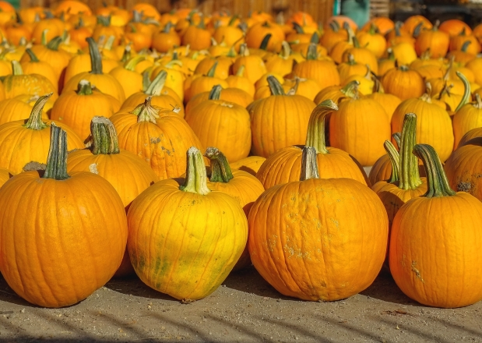

Pumpkins are a staple at Halloween, especially after they’ve been turned into jack o’ lanterns but columnist Naomi Lakritz would gladly see an end to the ‘holiday.’

Photograph by: JOE KLAMAR, AFP/Getty Images
It’s almost my least favourite day of the year again, Halloween. That’s why I was particularly interested in a letter to the editor published recently in the Calgary Herald, which suggested we abandon Oct. 31 as the official day for Halloween, and instead have it on the Saturday night closest to the 31st.
The rationale is if it’s on Saturday, parents won’t feel rushed coming home from work, fixing dinner, heading out with the kids and then hustling them off early to bed for school the next day. Also, the kids could spend Sunday resting from treats and tricks, and over-indulgence in candy.
Well, it’s a good thing Halloween is not one of those holidays that can be legislated, because a permanent annual Saturday night celebration is the worst possible idea for Halloween. If it ever came to pass that Halloween was relegated to Saturday nights, I’d be hoping for a blizzard and/or temperatures of -20 C on that night every year so the weather would put the kibosh on it.
If Halloween were to fall on Saturday night every year, can you imagine the cost in time and manpower to police departments? It’s bad enough already that it falls on Saturday night by chance, but if it were always celebrated on Saturday, there’d never be the kind of limits imposed on teens that school nights necessarily impose. Some would be out till the wee hours of Sunday morning, ringing doorbells, throwing eggs at people’s houses, vandalizing things, scrawling graffiti on people’s garage doors, flinging toilet paper into tree branches, and doing all the other idiotic things that are part of the usual Halloween havoc.
If Halloween was a holiday that could be legislated, then an all-out ban should be the goal. What a relief it would be to do away with the whole obnoxious concept.
There’d be no more discussion over the relative degrees of political correctness associated with various costumes. No more obsession that witch costumes offend Wiccans or that jailbird costumes make kids think being a prisoner is an acceptable career choice. No more tedious advice from “experts” that people hand out celery sticks, carrots and even toothbrushes to trick-or-treaters instead of candy. Anyone who would drop a toothbrush in a kid’s trick-or-treat bag deserves to have their front yard toilet-papered.
A ban would mean an end to the tiresome debate over whether Halloween lures kids into the occult and Satanism, along with that other equally tiresome debate: Whether schools should substitute wishy-washy harvest festivals for Halloween.
Banning Halloween would also put an end to adults co-opting it for themselves. Remember when there was an age past which your parents said you were too old for Halloween? Nor did your parents ever dress in Halloween costumes. Not any more. Forty is the new 10. Taht is why someone named Gillian Pensavalle is featured in the Philadelphia Inquirer with the note that “it’s sexy Halloween costume season,” and Pensavalle “has some odd suggestions if you’re looking to dress as something unexpected.” One of Pensavalle’s suggestions is a dress that’s a Coke can.
A few years ago, the Catholic League for Religious and Civil Rights noted that “this Halloween season ran out the common costumes depicting Jesus, priests, nuns, ministers, rabbis and imams.” Rabbis? Who goes out on Halloween dressed as a rabbi? To that one can only say: Adults, would you please grow up? Like Trix, Halloween is for kids.
Best of all, banning Halloween would end the nuisance of trick-or-treating which, if you don’t want to answer your door, means either you have to go out for the evening, even if you don’t feel like it, or sit in the dark, a prisoner in your own home, until the doorbell stops ringing. Leaving your porch light off as a sign you don’t want to be bothered doesn’t guarantee anything.
Yes, I’m beginning to sound as if I’m part of the demographic that growls, “You kids stay off my lawn!” but it’s my age cohorts turn to be curmudgeonly; those of us, that is, who aren’t out running around dressed as Coke cans or pregnant nuns.
Dressing in costumes has always seemed pointless, and I can’t bring myself to indulge in insincere cooing over the Halloween garb of some child at my door. I’m just not interested.
If you google “ban Halloween,” you yield with a bunch of sites that want to ban it for various religious reasons. That’s not why I’d like to see this holiday go the way of the dodo. Rather, it’s because Halloween is so intrusive.
I don’t want to be bothered with it, but the incessantly ringing doorbell and annoying shouts of “trick or-treat” from children I never see in the neighbourhood the rest of the year and don’t even know, force me to be bothered with it.
Then, there’s the occasional egg that has to be cleaned off my house’s siding, because even though I’ve dutifully handed out candy all evening at the door, some teens have passed by around midnight. And the purpose of this stupid holiday is what?
I’d love to see Halloween banned, or at least trick or-treating outlawed. Too bad there’s not a ghost of a chance that will ever happen.
Naomi Lakritz is a Calgary Herald columnist. She can be reached at nlakritz@calgaryherald.com
© Copyright (c) The Vancouver Su

