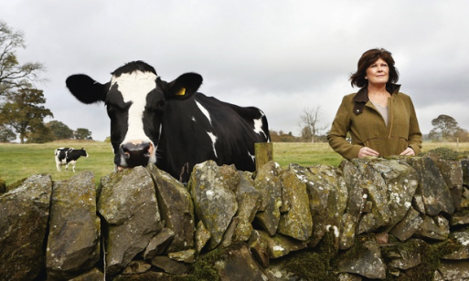
Experience: my horse saved me from a raging cow by Fiona Boyd.
It was a beautiful summer’s day, towards the end of July. I was busy in the kitchen of my Castle Douglas farmhouse, making tea for my two-year-old niece, Zara, and husband, Matt, who was working on our second dairy farm a mile away. Matt phoned to ask me to move a cow and its calf out of the paddock, which is only about 200 meters from the house, as there were other cows about to give birth there. Thinking nothing of it, I left Zara watching a DVD, with some potatoes simmering on the stove for tea as I assumed I’d just be briefly popping out.
The thing is with dairy cows, you have to separate the mothers from their calves when they are very young. It sounds horrible, but this is just what happens on a farm. You walk the two of them down to a special calf house, but then the mother is returned, on her own, to the milking parlor. So I began to walk behind the two-day-old calf to cross over the field. It was a little thing with its back reaching my knees, its head thigh high. Normally we’d expect the mother to just happily follow.
As they are nosey creatures, the other five cows in the paddock, all waiting to give birth, had gathered to saunter around the calf. Although I was huddled in by huge cows (I could just see over their enormous backs), I wasn’t alarmed as dairy cows are notoriously placid. I’m used to gently shifting them on with a pat. But as I was trying to move the calf, they became a bit flighty.
The confused calf started to bellow. Its three-year-old mother, in a panic, plowed into my left side. With her head she butted my shoulder, knocking me to the ground.
I’m a townie, but at that point in my life I’d been working with cows for more than 20 years. I’d always felt safe around them but now I became very wary. I’d been taught that once someone is on the ground dairy cows have been known to group together and attack en masse – to kill. I knew I had to be on my feet.
But the cow wouldn’t let me get back up. She kept pushing me back into the ground with her head. I was screaming but there was no one around to hear me. I shouted and tried to hit the beast’s face, but she was so powerful I couldn’t push her away.
The cow, 600kg and angry, was intent on attacking me. If I could have reached the barbed wire and electric fence about 15ft away I’d be safe, but she wouldn’t let me move. She was straddling me, and all I could see was her massive body looming over me.
Instinctively, I knew she was about to crush me. Terrified, I realized that escape was impossible, so I just gave up. All I could do was curl up into a little ball. I tucked my head under my arms to protect my neck, as I couldn’t bear the idea of the cow breaking it.
But then the cow moved away. I was stunned to see that my horse, Kerry Gold (who’d been in the same paddock), had galloped over and started kicking the cow with her back hooves. recognizing I was in trouble, she continued to lash out at the cow as I crawled away to safety under the electric fence. The cow left and Kerry stood protectively beside me as I cowered under the fence. My back was painful and I was sore all over, bruised and in tears. I needed to check on my niece, but was too scared to move. I stayed there for about a quarter of an hour until Matt, whom I’d managed to ring from the mobile I was carrying, came to help. Luckily, Zara, absorbed in her DVD, remained oblivious to it all.
I was tearful for days after, but had no lasting injuries – just cuts and bruises and a tender back. We rewarded Kerry Gold with extra apples and carrots, and she continued to protect me, and anyone else who entered her field, by walking along beside them like a bodyguard. It has been eight years since the incident – Kerry Gold died two years ago.
At the time, I suggested to my husband we have the cow shot. He disagreed – after all, it was one of his best.
- Fiona Boyd’s husband has been contacted by the local council who have received a complaint that he owns a dangerous cow. Write his response to the council.
Explain:
- what happened to his wife
- the reason his cow attacked
- why his cow should be allowed to continue to live on the farm
Write between 1 and ½ sides, depending on the size of your handwriting.
Begin your letter:
Dear local councilor,
I have recently received your letter regarding one of my cows…

